Assignment

1. Difference between let and var.

* In order to declare a variable in JavaScript we have two options either declare with var or declare with let. Now the question is when to use var and when to use let i.e., what are the major difference between both.

In the following text we come to know the major difference between var and let in JavaScript.

The main difference between let and var is that scope of a variable defined with let is limited to the block in which it is declared while variable declared with var has the global scope. So, we can say that var is rather a keyword which defines a variable globally regardless of block scope.

The scope of let not only limited to the block in which it is defined but variable with let also do not get added with global window object even if it gets declared outside of any block. But we can access variable with var from window object if it is defined globally.

Due to limited scope let variables are usually used when there is limited use of those variables such as in for loops, while loops or inside the scope of if conditions etc while var variable is used when value of variable need to be less change and used to accessed globally.

Also, one difference between var and let is variable with var can be redeclared to some other value while variable could not be redeclared if it is defined with let.

Example:

//Variables

//var => Variant

var x="Hello this is variable x using 'var' syntax!";

          console.log(x);

Output:

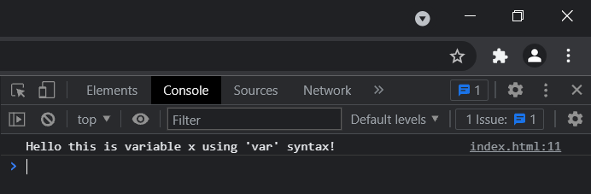

//let => variant

let name = "NewUser";

          console.log(name);

Output:

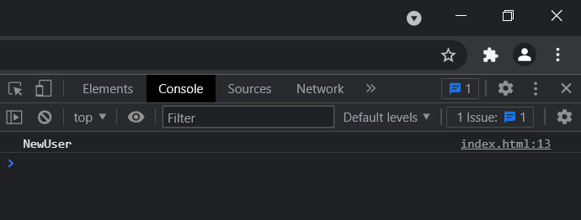

1. Why are null, array printed as object type in console.

* The value null represents the intentional absence of any object value.

It is one of JavaScript's primitive values and is treated as false for Boolean operations.

The value null is written with a literal: null.

null is not an identifier for a property of the global object, like undefined can be. Instead, null expresses a lack of identification, indicating that a variable points to no object.

In APIs, null is often retrieved in a place where an object can be expected but no object is relevant.

Syntax:

null

Example:

alert(typeof(null)); // object

alert(typeof(undefined)); // undefined

alert(null !== undefined) //true

alert(null == undefined)  //true

Output:

